**Table contents**

1. **Abstract……………………………………………………….. 2**
2. **Introduction………………………………….…………………2**
3. **System Requirement………………………………………….. 3**
4. **System Specification……………………………..………..….. 4**
5. **Working……………………………………………………….. 4**
6. **Parent Class………………………...………………… 8**
7. **Child Class…………………………………….…. 9**
8. **File Handling……………………………….…… 10**
9. **Deposit Cash………………………………….… 13**
10. **Withdraw Cash ...…………………………..….. 14**
11. **Account Details …………………………..……. 16**
12. **Pay Bills …………………………………………..18**
13. **Pay Account Interest ……………………….19**
14. **Exit Program………………………………………20**
15. **Conclusion…………………………………………………………21**

**ABSTRACT:**

The ATM system is the project which is used to access the bank accounts in order to make cash withdrawals or Cash deposit. Whenever the user need to make cash withdraws, they can enter their PIN and it will display the amount to be withdrawn. Once their withdrawn was successful, the amount will be debited in their account. This mini project contains fewer features but the essential ones.

ATM come in a variety of form and sizes all to serve on goal; bring the bank closer to the user. ATMs have certain characteristics that need to be fulfilled at all times one of them is security. ATMs now are so advanced they can communicate with each other even if different Banks. In this Project, designing and the implementation of ATM system has been conducted using an Object Oriented Programming language along with the necessary tool such as Dev C++. The use case took place; and the requirements were analyzed and based on the analysis the design took place; and basing on it the implementation is done based on object oriented concepts under C++ with code in Dev Cpp 5.11.

In our ATM system, the transactions are done in person by the customer thus makes the customers feel safe and secure. Thus the application of our system helps the customer in checking the balanced transaction of the amount by validating the pin number therefore ATM system is more user friendly.

The ATM will provide the customer with a printed receipt for each successful transaction, showing the date, time, type of transaction, account amount, ending and available balance of the affected account.

The automated teller machine was invented by john Shepherd-Barron in the year of 1960.

**INTRODUCTION:**

ATM is a part of our life activity, which helps us in day transactions and business. An automated teller machine (ATM) is a computerized telecommunications instrument that provides the clients of a financial institution with access to financial transactions in a public space without the need for a cashier, human clerk or bank teller. At this time, the ATM provides the people good services especially the people can get money at any time.

We need the ATM system because not all the bank branches are open all days of the week, and some of the customers may not in a situation, they can visit the bank every time, and they want to withdraw money or deposit money for emergency cases. The main objective of this research is to implement and design the ATM system through identify the requirements of the ATM system. The ATM will act as a second person that a customer can talk to; the customer makes choices that ATM replies back accordingly.

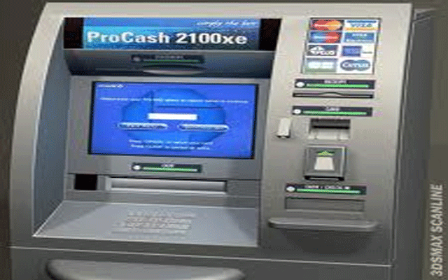

ATM SYSTEM REQUIREMENTS:

Generally the interaction type is conversing. Therefore, it is very necessary to know the requirements of ATM before design and implement the ATM system like any system. System users and the role of each user is the main concerns have to be considered; to start design and implement the ATM system. ATM system has many users; the first is the operator, who should be able to do turning the ATM in ON/OFF status using the designated Key Switch, refilling the ATM with cash. Refill ATM's printer with receipts.

The second user of ATM is the customer who should be able to make cash withdrawal from any suitable account linked to the card. So to do this step the customer should have an account and this account approved from the bank. To make a system is more interest for the customer; the ATM system provides the customer to print a receipt after each successful withdrawal transaction. A customer must be able to make a deposit to any account linked to the card, consisting of cash and/or checks in an envelope. In addition, customer also pay bills. Moreover, the customer must be able to make a balance inquiry of account. ATM system should provide a good service so the system needs security, especially some of the users do mistakes when the insert the pin number; to solve this state the ATM system will allow the system user to insert the pin wrongly for three times only. If the system user inserts the pin wrongly for three times; the ATM system will keep the user card, and he should go to the bank to take it. ATM system should provide the customer for all functions that I mentioned above

The manager is also a user of the ATM system; which has several functions to do it in the ATM system such as the check the total deposits, total withdrawals and print them. The officer is another user who has some functions in ATM system to do it, such as check total deposits, total withdrawals and keep track number of transactions that were execute every day. Bank validation for each user is the main consideration; it should be ensued to perform all ATM users’ functions. So each system user needs the bank validation to perform any transaction.

**ATM SPECIFICATIONS:**

The main components of the ATM that will affect the interaction between ATM and its users are:

1. **Key-Switch**: to startup (ON) or shutdown (OFF) of the ATM machine.

2. **Card-Reader**: to read the users ATM-cards (magnetic stripe reader).

3. **Screen:** to display the messages to the users.

4. **Key-Pad:** to enter the information to the ATM e.g. PIN.

5. **Cash-Dispenser**: for dispensing cash.

6. **Deposit-Slot:** to deposit cash or checks from the users.

7. **Printer:** for printing the receipts.

8. **Communication/Network Infrastructure:** it is assumed that the ATM has a communication infrastructure to communicate with the bank upon any transaction or activity.

WORKING:

The automated teller machine (ATM) is an automatic banking machine that allows the customer to complete basic transactions without any help from bank representatives.  There are two types of automated teller machines (ATMs). The basic one allows the customer to only draw cash and receive a report of the account balance. Another one is a more complex machine that accepts the deposit, provides credit card payment facilities and reports account information.

It is an electronic device that is used by only bank customers to process account transactions. The users access their accounts through a special type of plastic card that is encoded with user information on a magnetic strip. The strip contains an identification code that is transmitted to the bank’s central computer by modem. The users insert the card into ATMs to access the account and process their account transactions.

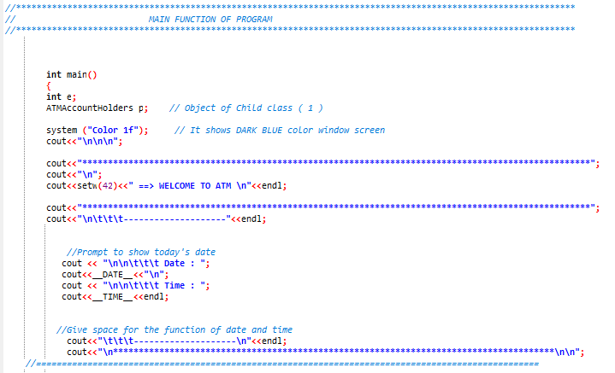Fig (1.1)

This is the main Function of Program where Program starts in fig (1.1). In this code we use “color 1f” for Dark Blue Colour of window screen. We use manipulator for welcome screen which is setw. Here we code for current Date and Time to show on receipt slip.

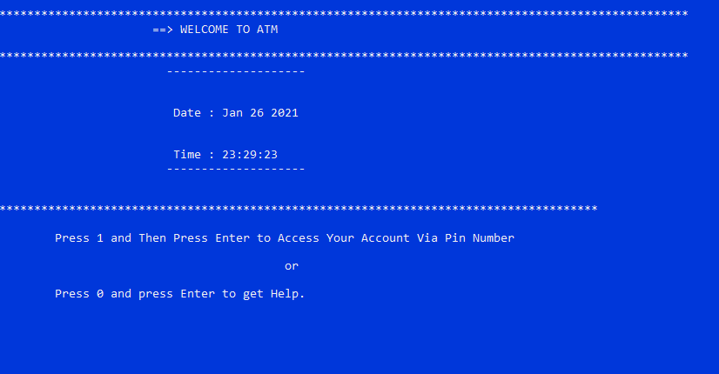Fig (1.2)

This is the output of Program which show current Date and Time. To continue Press 1 and to get help press 0, see in fig(1.2).

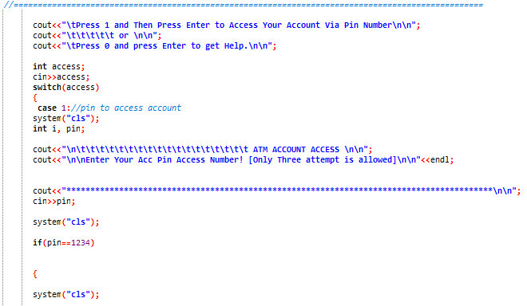Fig (1.3)

In fig (1.3) User can enter Pin to access ATM Account, User can enter wrong pin for two times if he enter wrong pin for third time, Machine take his/her ATM card then User has to take back his card from bank.

**Switch Statement:**

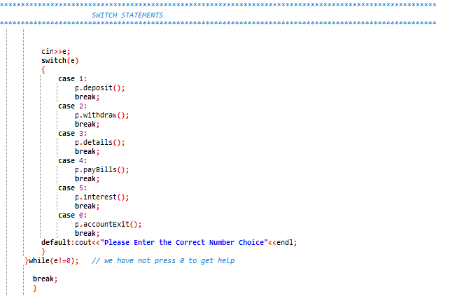Fig (1.4)

In the fig (1.4) if user enter correct pin to access hi/her account then this switch statement will be executed.

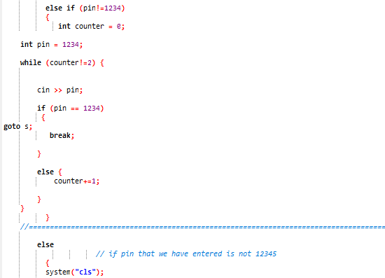

Fig (1.5)

In this fig we use “goto s” statement and we set three tries for user to enter his/her account pin, if user enter wrong pin for third time then ATM take user take and user has to take his card from bank.

**Header Files:**

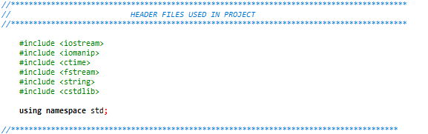

Fig (1.4)

These are the Header files used in the project.

#include <iostream> is used for input and output values which we use in the program.

#include <iomanip> is used to set field width.

#include <ctime> is used to display current Date and Current Time.

#include <fstream> is used for File handling.

#include <string> is use to write strings in a program.

#include <cstdlib> this is standard library of C++.

Using namespace std is used to read “cin” and “cout” statements.

**Parent Class:**

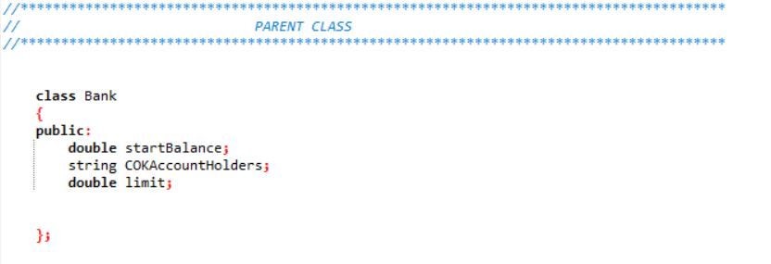

Fig (1.5)

This is the parent class which is Bank in this we use public mode of visibility.

**Child Class 1:**

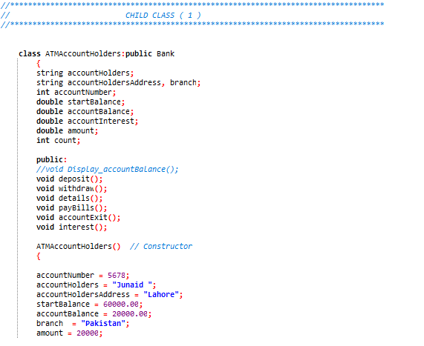Fig (1.6)

Base class Bank is inherited in derived class account holder with public mode of visibility.

**Private Mode:**

In this class we have declared private members like account holder name, address, Balance, interest etc. Next in public mode we have declared some function for modules which are deposit, withdraw, details, paybills, accountExit, interest.

**Public Mode:**

Next we use *constructo*r through which we initialize account holder details like account number, balance, branch, amount etc.

**File Handling:**

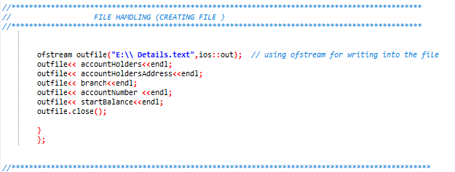Fig (1.7)

In this fig we use file handling to write data into the file name “Details”.

**OUTPUT:**

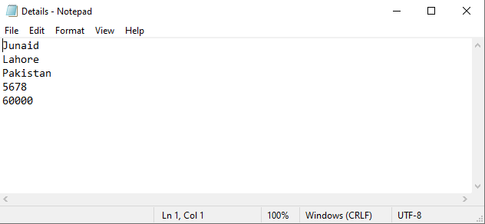

Fig (1.8)

This is the file on disk.

**Child Class 2**:

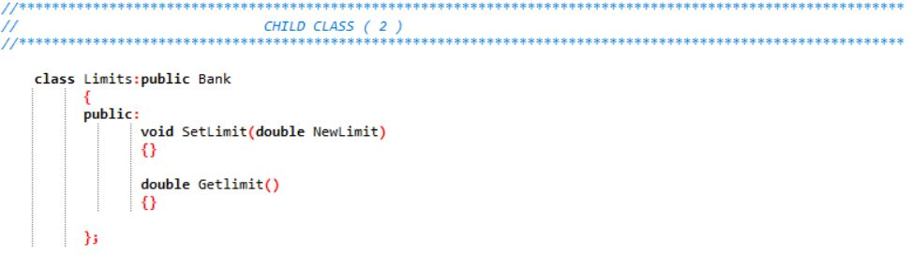

Fig (1.9)

**Modules:** 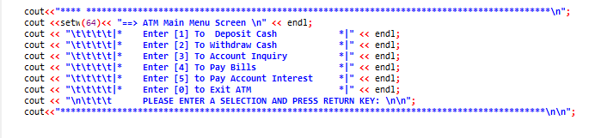 Fig (1.10)

In this block of code shown in Figure (1.5), System has six main options, “Deposit cash, Withdraw Cash, Account Inquiry, Pay Bills, Pay Account Interest and sixth option is Exit program”. All options are labeled with a serial number respectively. It will take a number that will be a serial number (1,2,3,4,5 and 0) which is labeled with the particular option shown in Figure (1.5).

**1.** Deposit Cash

**2**. Withdraw Cash

**3.** Account Inquiry

**4.** Pay Bills

**5.** Pay Account Interest

**6**. Exit Program

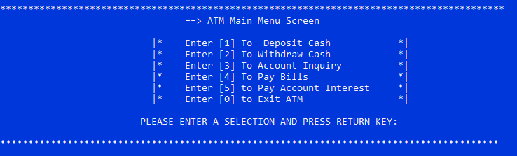Fig (2.1)

This is the output of modules where user can select multiple options.

**DEPOSIT CASH:**

This is first option which consists of deposit cash. It is activated when user enters “1”. Here user deposit amount in the account which he want to and amount will add up to the balance in the user account. After adding amount new balance is shown to the user. Its code is shown below:

**Code:**

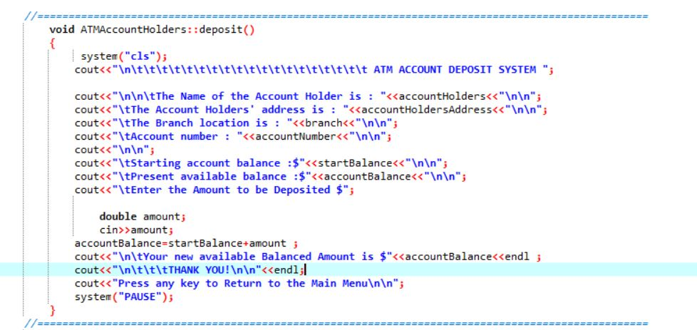Fig (2.2)

**Output:**

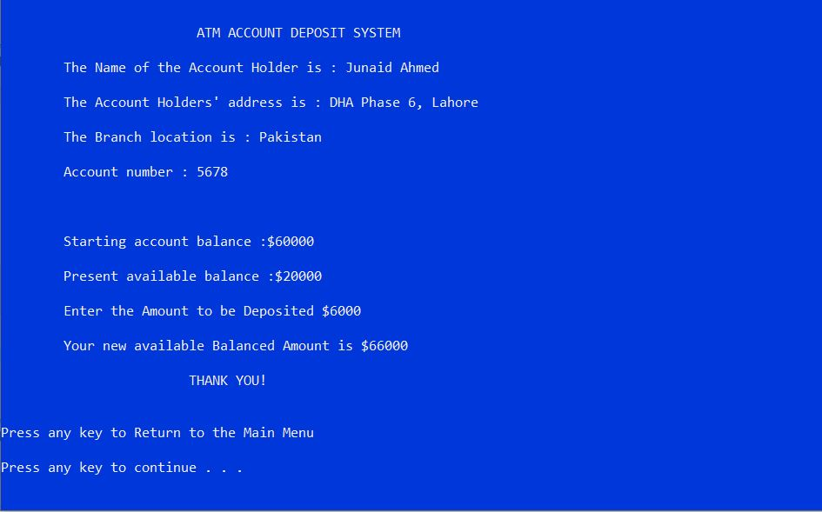

Fig (2.3)

In fig (2.3) is the output of code for deposit cash.

**WITHDRAW CASH:**

This is second option which consists of withdraw amount. It is activated when user enters “2” from the keyboard. We use “if-else” statement and here are two options if the user withdraw amount greater than the current balance in the account than message will display that “Insufficient Available Balance in your account” see in figure (2.5) and the other option is if you with draw amount according to current balance in the account than after withdrawing user will see the remaining balance. See in figure (2.4.). Its code is shown below:

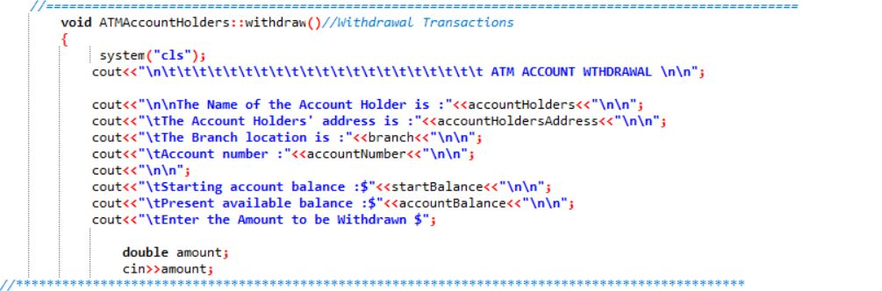

Fig (2.4)

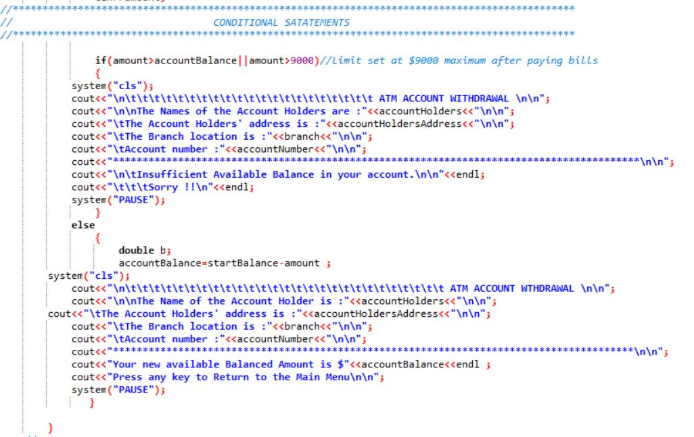Fig (2.5)

**OUTPUT:**

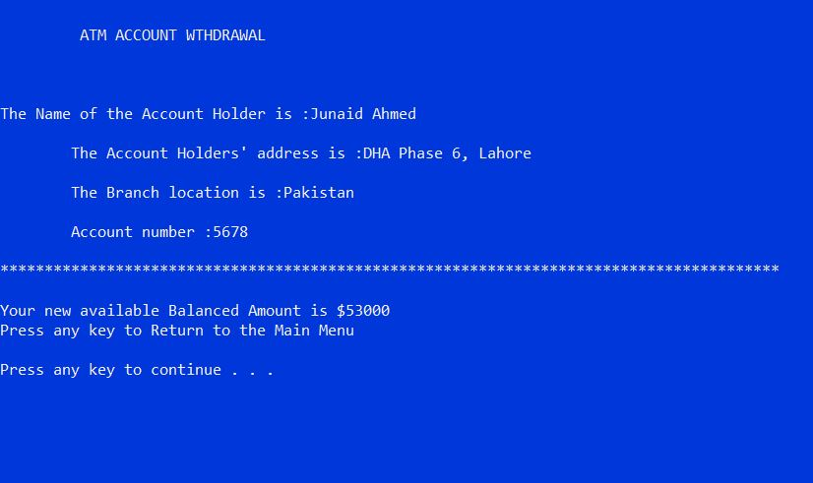Fig (2.6)

**ACCOUNT DETAILS:**

This is third option which consists of Account Details. It is activated when user enters “3” from the keyboard. We use “File handling” statement for reading given details of user Account and here user can check details of his/her ATM account. Its code is shown below:

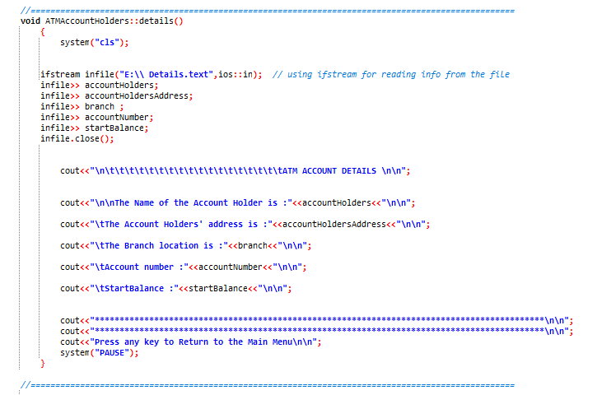Fig (2.7)

**OUTPUT:**

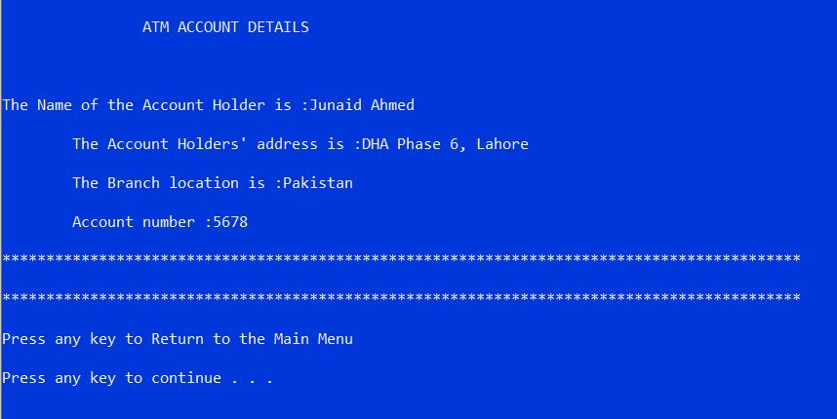Fig (2.8)

**PAY BILLS:**

This is fourth option which consists of Pay Bills. It is activated when user enters “4” from the keyboard. We use “if” statement and here user have two option either he wants to pay bills or not, for paying bills user has to enter “1” or enter “0” for not paying. Its code is shown below:

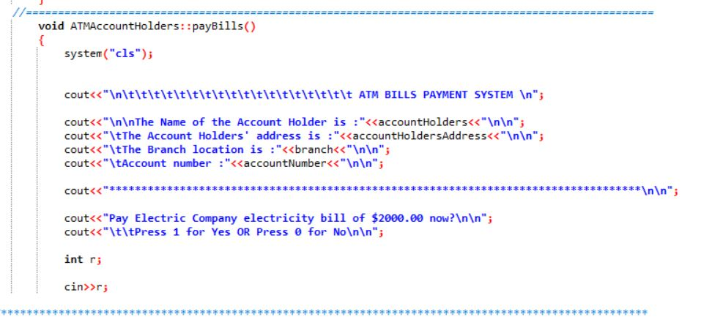Fig (2.9)

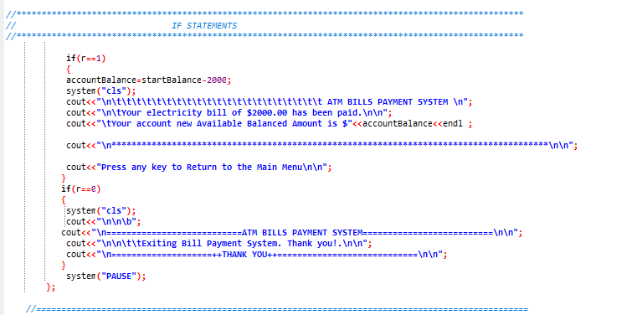Fig (2.10)

**OUTPUT:**

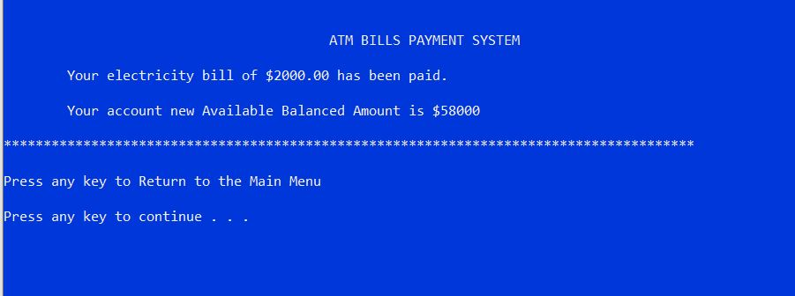Fig (3.1)

**PAY ACCOUNT INTEREST:**

This is Fifth option which consists of Pay Account Interest. It is activated when user enters “5” from the keyboard. Its code is shown below:

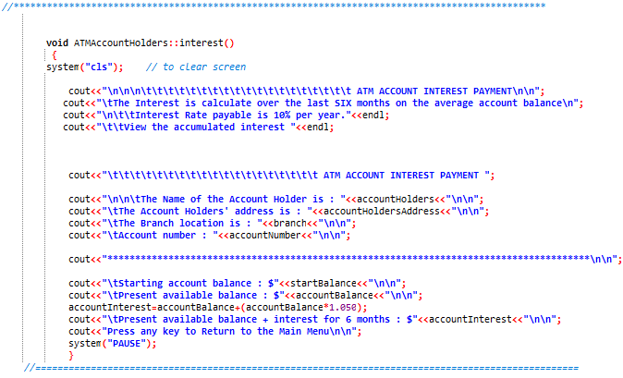Fig (3.2)

**OUTPUT:**

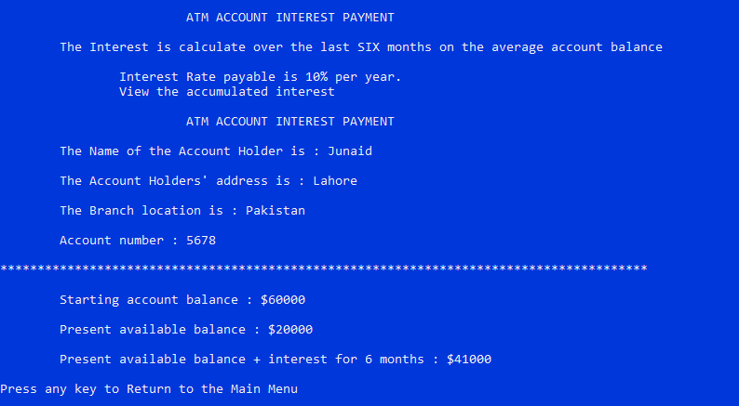Fig (3.3)

**EXIT ACCOUNT:**

This is Sixth and last option that will stops the program execution. When user select this option and enters ‘0’ then the program exit. Its code is shown below:

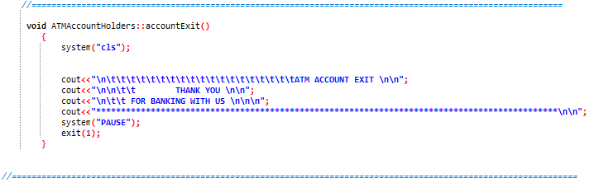Fig (3.4)

**OUTPUT:**

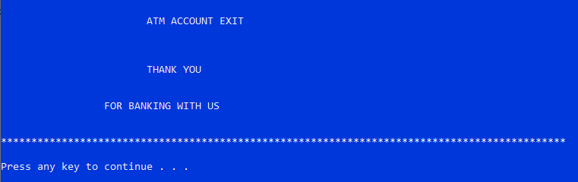

Fig (3.4)

**Conclusion:**

ATM come in a variety of form and sizes all to serve on goal; bring the bank closer to the user. ATMs have certain characteristics that need to be fulfilled at all times one of them is security.

ATMs now are so advanced they can communicate with each other even if different Banks. When one looks at the different ATM they all share several operations such that withdrawal and View Balance. The requirements of ATM machine came to clarity especially when the use case took place; and the requirements were analyzed and based on the analysis the design took place; and basing on it the implementation done based on object oriented concepts.